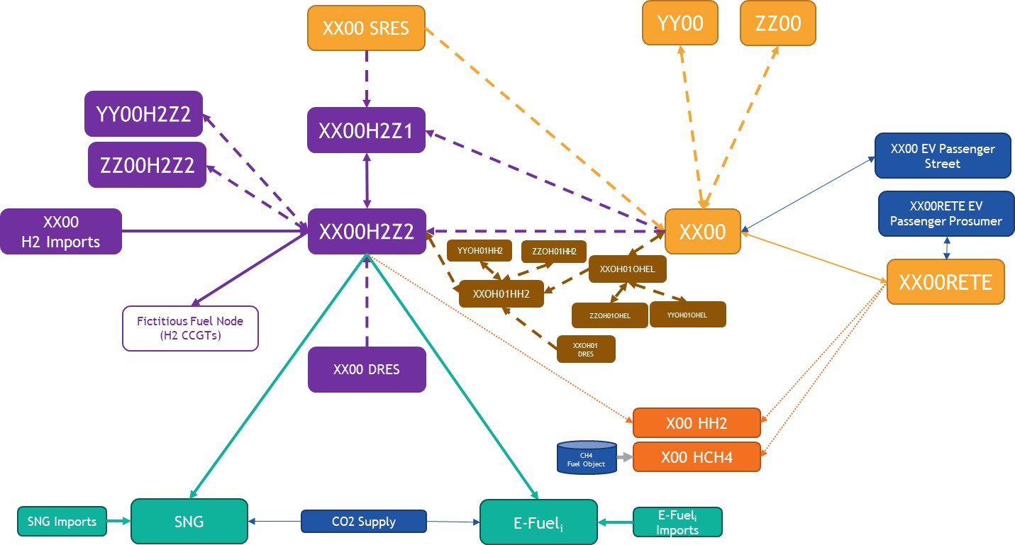

* **MMStandardOutputFile_DE2050_Plexos_CY2009_v11**: Electricity results

**Nodes:**

|  |  |  |  |  |
| --- | --- | --- | --- | --- |
| XX00 | XX00 EV Passenger Prosumer | XX00 EV Passenger Street | XX00 SRES | XX00RETE |
| Emarket node | EV node charging in Prosumer node | EV node charging in emarket | Shared RES node | Prosumer node |

**Technologies:**

|  |  |
| --- | --- |
| Nuclear [MW] |  |
| Lignite old 1 [MW] |  |
| Lignite old 2 [MW] |  |
| Lignite new [MW] |  |
| Lignite CCS [MW] |  |
| Hard coal old 1 [MW] |  |
| Hard coal old 2 [MW] |  |
| Hard coal new [MW] |  |
| Hard coal CCS [MW] |  |
| Gas conventional old 1 [MW] |  |
| Gas conventional old 2 [MW] |  |
| Gas CCGT old 1 [MW] |  |
| Gas CCGT old 2 [MW] |  |
| Gas CCGT new [MW] |  |
| Gas CCGT CCS [MW] |  |
| Gas OCGT old [MW] |  |
| Gas OCGT new [MW] |  |
| Gas CCGT present 1 [MW] |  |
| Gas CCGT present 2 [MW] |  |
| Light oil [MW] |  |
| Heavy oil old 1 [MW] |  |
| Heavy oil old 2 [MW] |  |
| Oil shale old [MW] |  |
| Oil shale new [MW] |  |
| Run-of-River [MW] |  |
| Reservoir [MW] |  |
| Pump Storage - Open Loop (turbine) [MW] |  |
| Pump Storage - Open Loop (pump) [MW] |  |
| Pump Storage - Closed Loop (turbine) [MW] |  |
| Pump Storage - Closed Loop (pump) [MW] |  |
| Pondage [MW] |  |
| Wind Onshore [MW] | Generation potential (real generation + energy curtailed) |
| Wind Offshore [MW] | Generation potential (real generation + energy curtailed) |
| Solar (Photovoltaic) [MW] | Generation potential (real generation + energy curtailed) |
| Solar (Thermal) [MW] | Generation potential (real generation + energy curtailed) |
| Others renewable [MW] | Generation potential (real generation + energy curtailed) |
| Others non-renewable [MW] |  |
| Lignite biofuel [MW] |  |
| Hard Coal biofuel [MW] |  |
| Gas biofuel [MW] |  |
| Light oil biofuel [MW] |  |
| Heavy oil biofuel [MW] |  |
| Oil shale biofuel [MW] |  |
| Battery Storage discharge (gen.) [MW] |  |
| Battery Storage charge (load) [MW] |  |
| Electrolyser (load) [MW] | XX00 node: emarket-to-H2Z1 and emarket-to-H2Z2 electrolysers (electricity demand)  SRES node: SRES-to-H2Z1 electrolyser (electricity demand) |
| Hydrogen Fuel Cell [MW] |  |
| Hydrogen CCGT [MW] |  |
| Demand Side Response [MW] |  |
| CH4 Heat Pump (load) [MW] | Electricity for CH4 Hybrid Heat Pump |
| H2 Heat Pump (load) [MW] | Electricity for H2 Hybrid Heat Pump |
| Demand [MW] (losses included) | Includes Native Demand, Fixed Exchanges (with extra-EU countries), some DSR in DE00  (electricity load) |
| Balance [MW] | Emarket: includes Prosumer and SRES connections, crossborder interconnections and electricity for/from EV (<0: injection in Emarket node)  Prosumer: includes emarket connection and electricity for/from EV (<0: injection in Prosumer node)  EV: includes emarket/Prosumer connections (<0: injection in EV node) |
| Dumped Energy [MW] |  |
| Energy Not Served [MW] |  |
| Marginal Cost [€] |  |

**Lines** (‘Node From – Node To’)

|  |  |
| --- | --- |
| XX00-YY00 (“”/”Real”/”Concept”) | “”: Reference grid interconnection  “Real”: Real candidate  “Concept”: Conceptual candidate |
| XX00-XX00RETE | Emarket - Prosumer connection |
| XX00-XX00EV | Electricity for EV in emarket node |
| XX00EV-XX00 | V2G in emarket node (injection in emarket node) |
| XX00RETE-XX00EV | Electricity for EV in Prosumer node |
| XX00EV-XX00RETE | V2G in Prosumer node (injection in Prosumer node) |
| XX00 SRES - XX00 | SRES-to-emarket connection |

* **MMStandardOutputFile_DE2050_Plexos_CY2009_H2_v11**: Hydrogen results

**Nodes**:

|  |  |  |  |
| --- | --- | --- | --- |
| XX00 DRES | XX00 SRES | XXH2Z1 | XXH2Z2 |
| Dedicated RES node | Shared RES node | H2Z1 node | H2Z2 node |

**Technologies:**

|  |  |
| --- | --- |
| H2 storage discharge (gen.) [MWH2] |  |
| H2 storage charge (load) [MWH2] |  |
| Steam methane reformer [MWH2] |  |
| DRES Solar PV [MW] |  |
| DRES Wind Onshore [MW] |  |
| DRES Wind Offshore [MW] |  |
| H2 Boiler (load) [MWH2] | H2 for H2 Hybrid Heat Pump Boiler (H2 demand) |
| H2 for power generation (load) [MWH2] | H2 for H2 CCGTs and fuel cells (H2 demand) |
| Demand [MWH2] (losses included) |  |
| Balance [MWH2] | Includes electrolysers, interconnections, imports, H2 for synfuel (see detail in the crossborder sheet) |
| Dumped Hydrogen [MWH2] |  |
| Hydrogen Not Served [MWH2] |  |
| Marginal Cost [€/MWH2h] |  |

**Lines:**

|  |  |
| --- | --- |
| XX00 EL H2Z1 | emarket-to-H2Z1 electrolyser (H2 injection in H2Z1 node) – ref.grid |
| XX00 EL H2Z1 Expansion 2035/2040/2045/2050 | emarket-to-H2Z1 electrolyser (H2 injection in H2Z1 node) – expansion candidates |
| XX00 EL H2Z2 | emarket-to-H2Z2 electrolyser (H2 injection in H2Z2 node) – ref.grid |
| XX00 EL H2Z2 Expansion 2035/2040/2045/2050 | emarket-to-H2Z2 electrolyser (H2 injection in H2Z2 node) – expansion candidates |
| XX00 SRES EL H2Z1 Expansion 2035/2040/2045/2050 | SRES-to-H2Z1 electrolyser (H2 injection in H2Z1 node)  – expansion candidates |
| XX00 DRES EL H2Z2 Expansion 2035/2040/2045/2050 | DRES-to-H2Z2 electrolyser (H2 injection in H2Z2 node)  – expansion candidates |
| XX-YY (“” / “Expansion”) | “”: Reference grid crossborder interconnection  “Expansion”: Expansion candidate |
| XXH2Z1-XXH2Z2 | H2Z1-to-H2Z2 connection |
| XXH2Z2-e-diesel | H2 for e-diesel (H2 demand) |
| XXH2Z2-e-kerosene | H2 for e-kerosene (H2 demand) |
| XXH2Z2-sng | H2 for sng (H2 demand) |

* **MMStandardOutputFile_DE2050_Plexos_CY2009_Heat_SynthFuels_v11**: Heat and Synthetic Fuel results

**Heat:**

**Nodes:**

|  |  |
| --- | --- |
| XX00 HCH4 | XX00 HH2 |
| CH4 Hybrid Heat Pump node | H2 Hybrid Heat Pump node |

**Technologies:**

|  |  |
| --- | --- |
| H2 Boiler [GJ] | H2 Boiler Heat production |
| CH4 Boiler [GJ] | CH4 Boiler Heat production |
| Electric Heat Pump [GJ] | Electric Heat Pump Heat production |
| Heat Demand [GJ] |  |
| H2 Boiler H2 usage [MWH2] | H2 for H2 Hybrid Heat Pump Boiler |
| CH4 Boiler CH4 Offtake [GJ] | CH4 for CH4 Hybrid Heat Pump Boiler |
| Electric Heat Electrical Usage [MW] | Electricity for H2/CH4 Hybrid Heat Pump |
| Heat Not Served [GJ] |  |

**Synthetic Fuels:**

**Nodes:**

|  |  |  |
| --- | --- | --- |
| e-diesel | e-kerosene | sng |
| Node with ediesel demand | Node with ekerosene demand | Node with sng demand |

**Domestic/import synfuel production:**

|  |  |
| --- | --- |
| Domestic production [MWSynfuel] |  |
| Imports [MWSynfuel] |  |
| Demand [MWSynfuel] |  |
| Demand Not Served [MWSynfuel] |  |
| CO2 [tons] |  |

**Lines:**

|  |  |
| --- | --- |
| XXH2Z2-e-diesel | H2 injection in e-diesel node (≠ H2Z2 H2 demand for e-diesel) |
| XXH2Z2-e-kerosene | H2 injection in e-kerosene node (≠ H2Z2 H2 demand for e- kerosene) |
| XXH2Z2-sng | H2 injection in sng node (≠ H2Z2 H2 demand for sng) |

* **MMStandardOutputFile_DE2050_Plexos_CY2009_offshore_v11:** Offshore hubs results